- State the following functions: Partial, Constant and Total. (3 M)

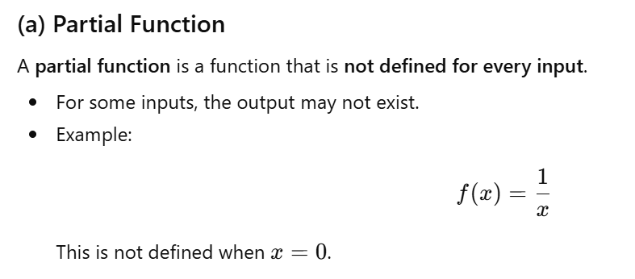
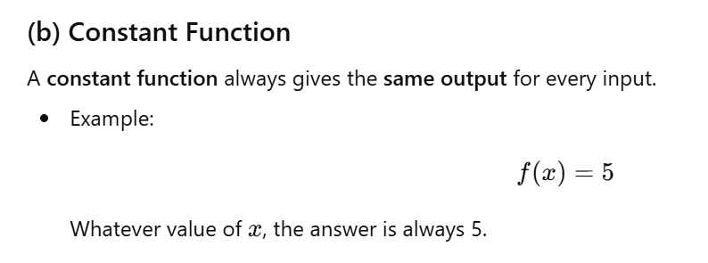
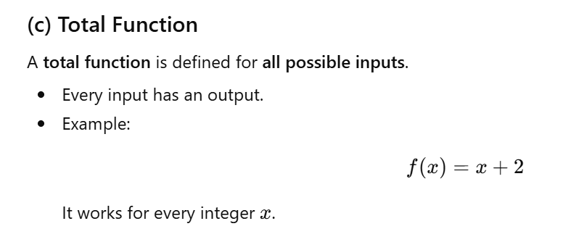

- Primitive Recursive Functions. (3M, 4M, 7M)
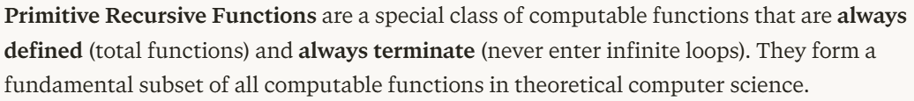

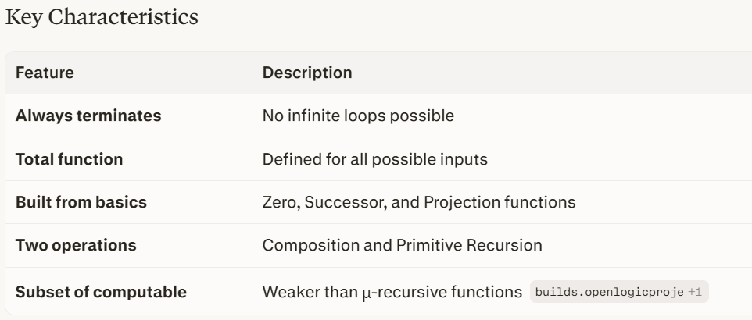
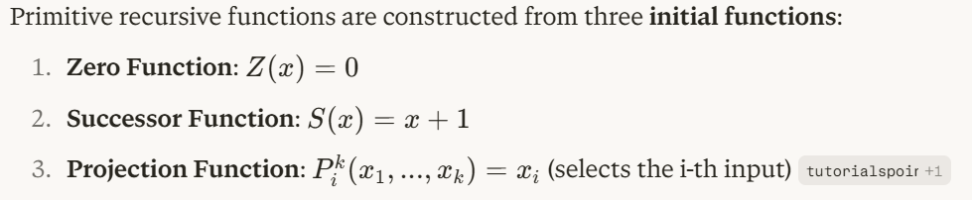

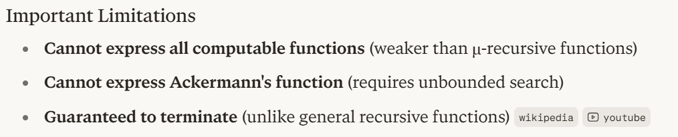

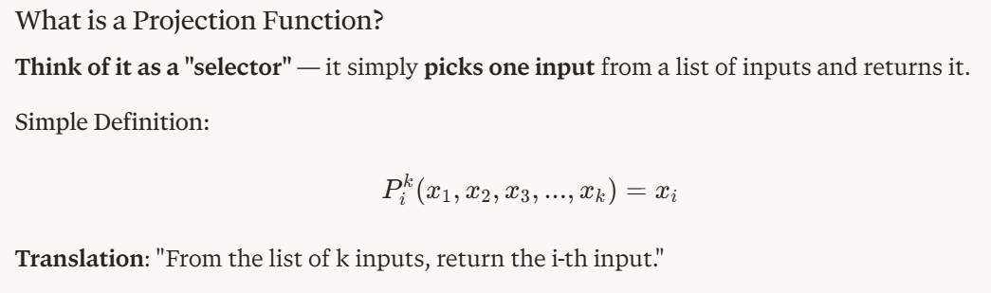
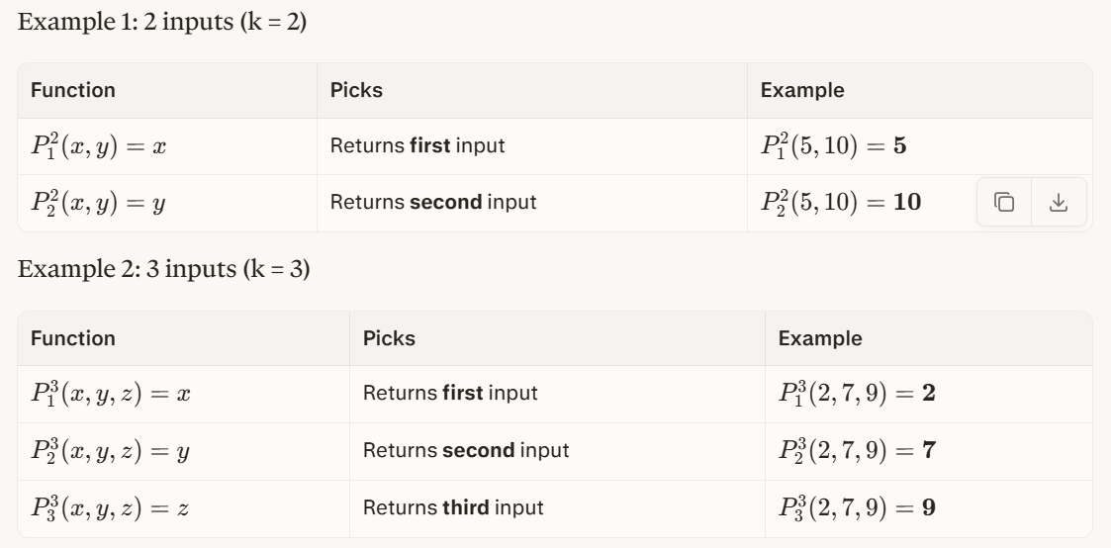

Example: Addition
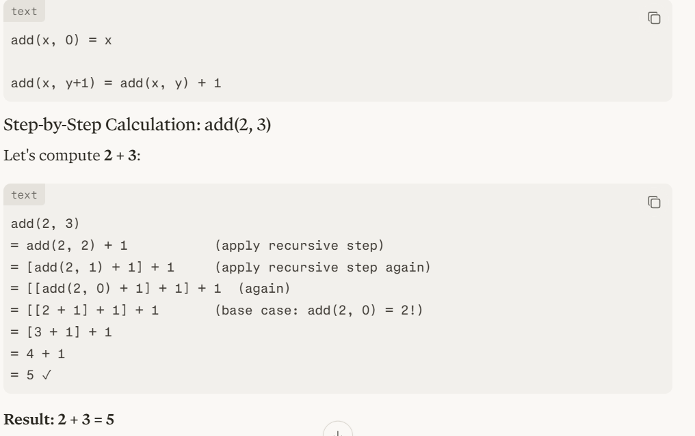

Example: Multiplication
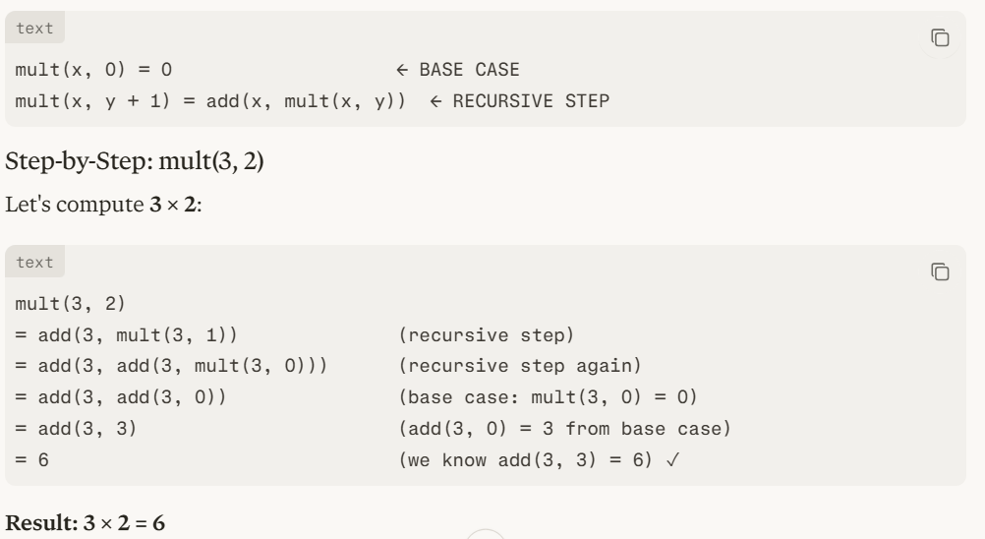

- Describe Recursive function. Prove every recursive function is computable.

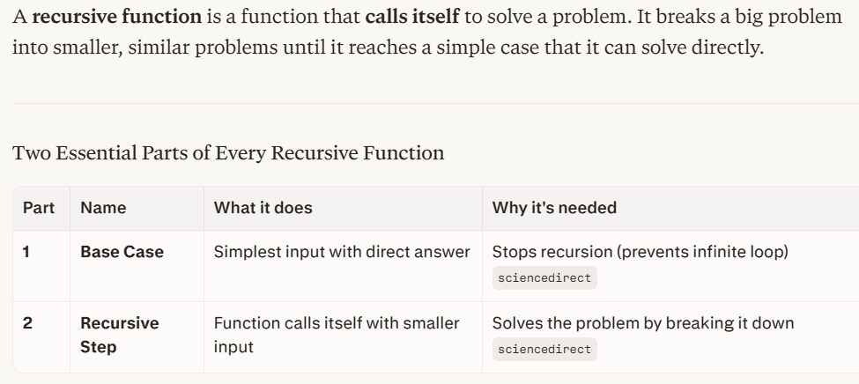

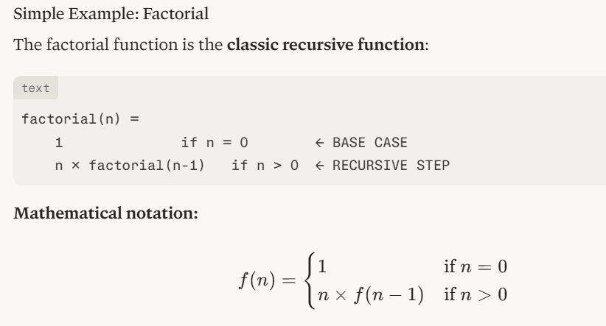

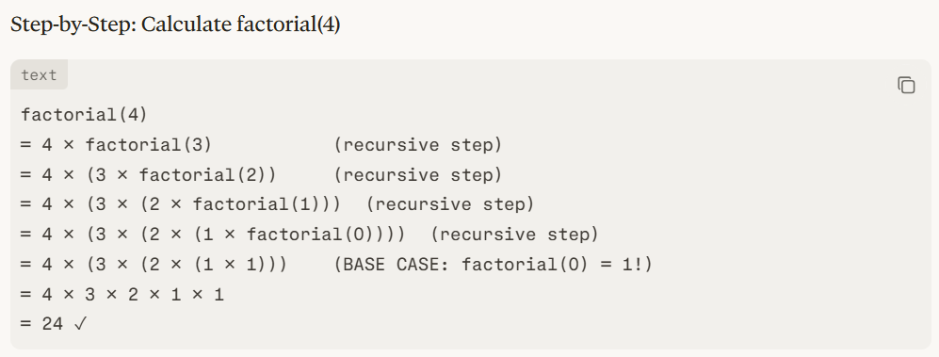

Proof That Every Recursive Function is Computable
What Does "Computable" Mean?
A function is computable if there exists an algorithm (or Turing Machine) that can calculate it for any valid input.

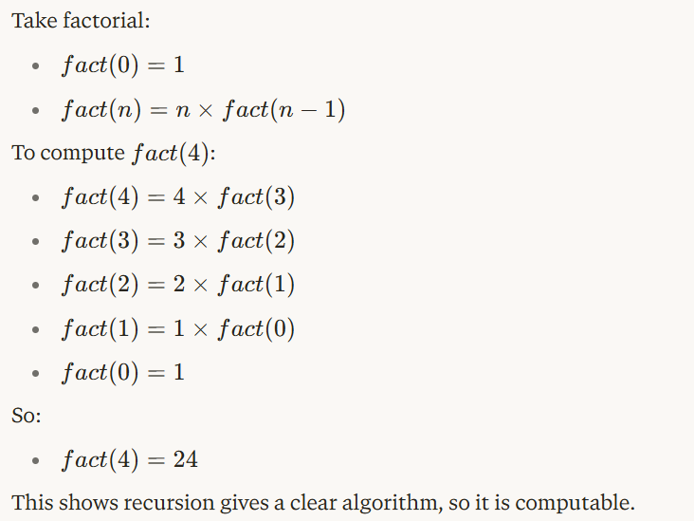

A recursive function in computability theory is a function defined using formal rules like:

- zero function,
- successor function,
- projection function,
- composition,
- primitive recursion,
- sometimes minimization.

These rules are mechanical. That is why such a function can be computed by a step-by-step algorithm.

Why it is computable: To show a function is computable, we only need to show that a machine or algorithm can calculate it in finite steps.

Now look at the building blocks:
- Zero function: always gives 0.
- Successor function: adds 1.
- Projection function: just selects one input.

These are obviously computable.

Then:
- Composition means combining computable functions.
- Primitive recursion means defining a function using a base case and then repeatedly using smaller values.

If each small part is computable, then the whole function is computable.

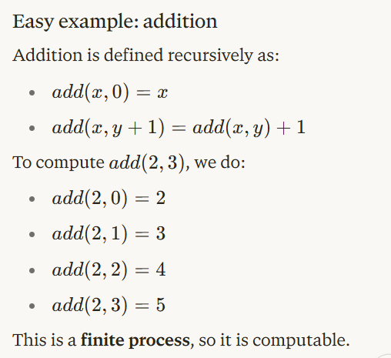

Recursive functions are obtained from the basic computable functions zero, successor, and projection by using composition and primitive recursion. Since the basic functions are computable, and composition and primitive recursion preserve computability, every recursive function can be calculated by an algorithm. Hence every recursive function is computable.

Difference between Primitive Recursive Function and Recursive Function
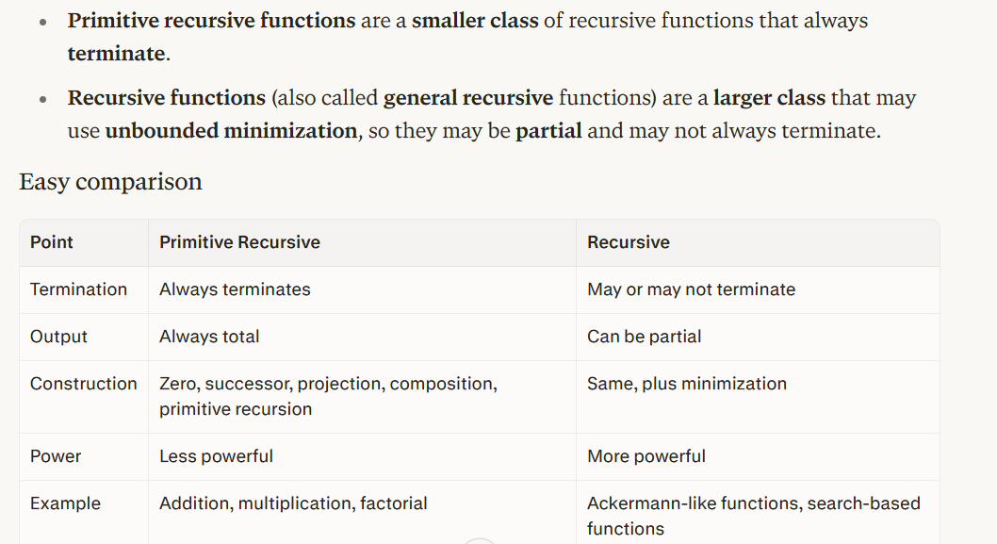
4. Prove that for two recursive languages L1 and L2 their union and intersection is recursive. (7 M)
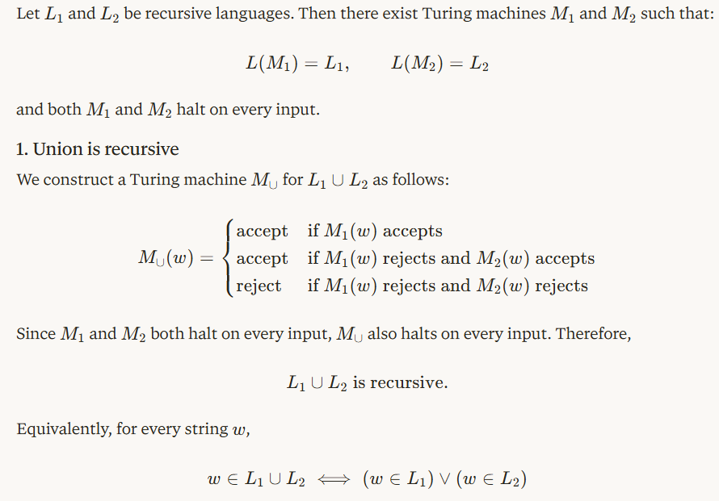
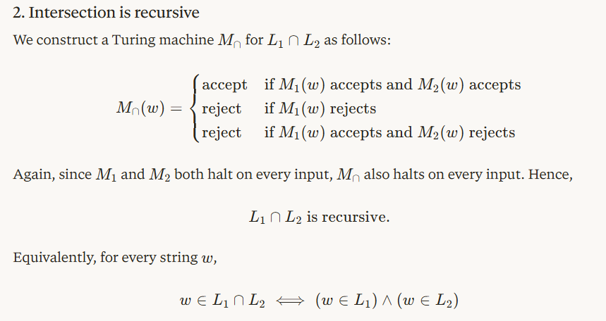

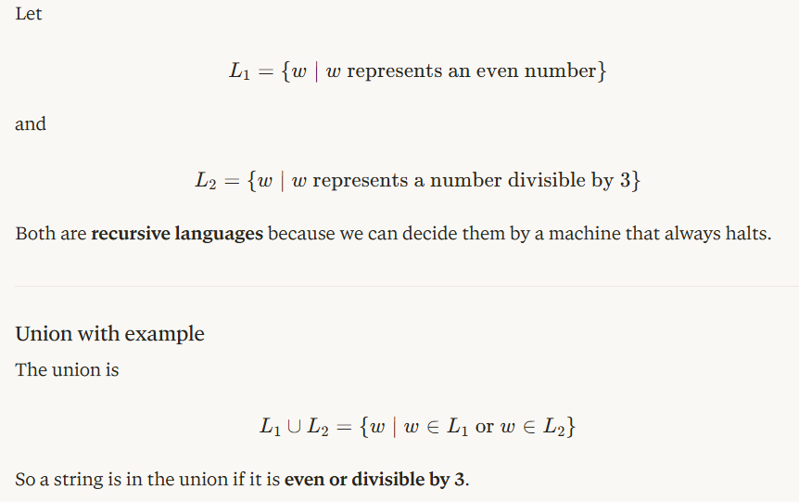

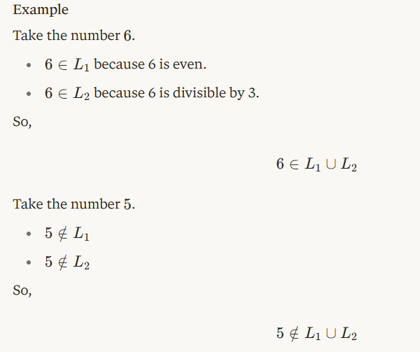
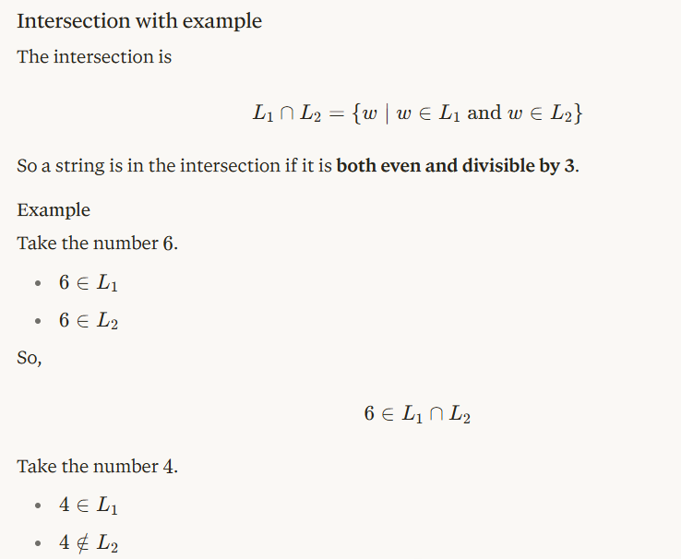
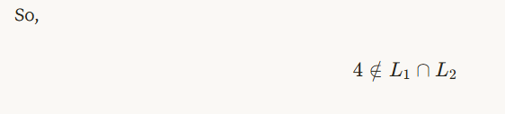

5. Discuss μ-recursive functions (3 M)
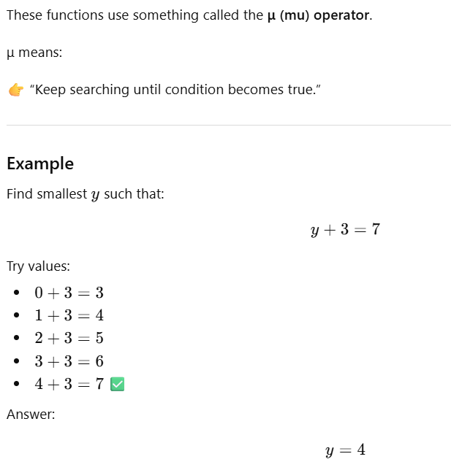
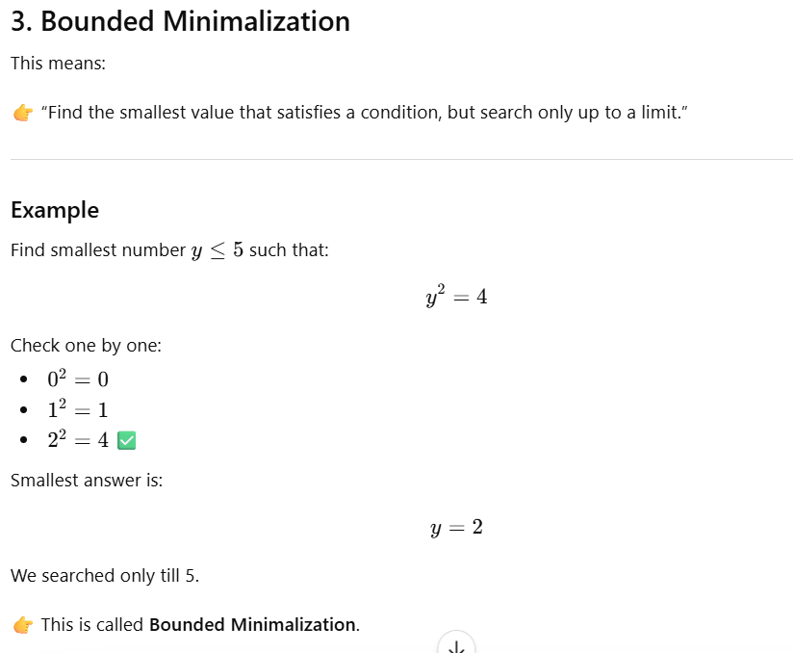
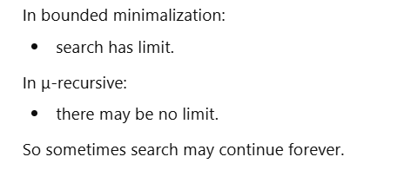

6. Define: Bounded Minimalization and show that, if P is a primitive recursive (n + 1) place predicate, bounded minimalization m is a primitive recursive function. (7 M)
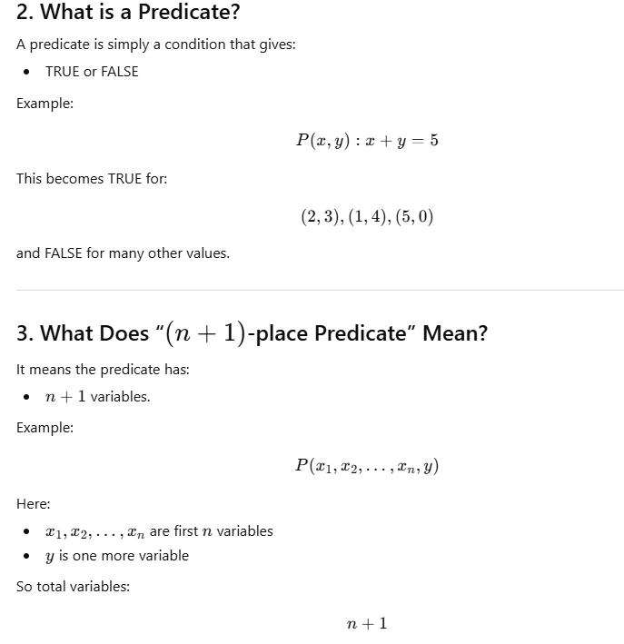
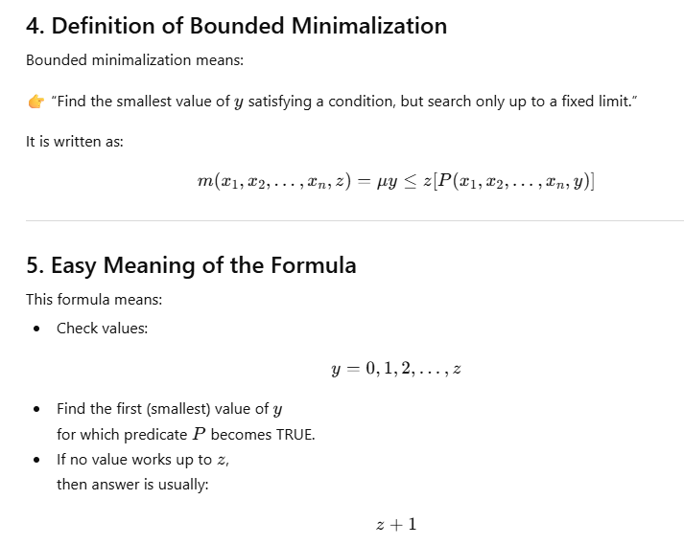
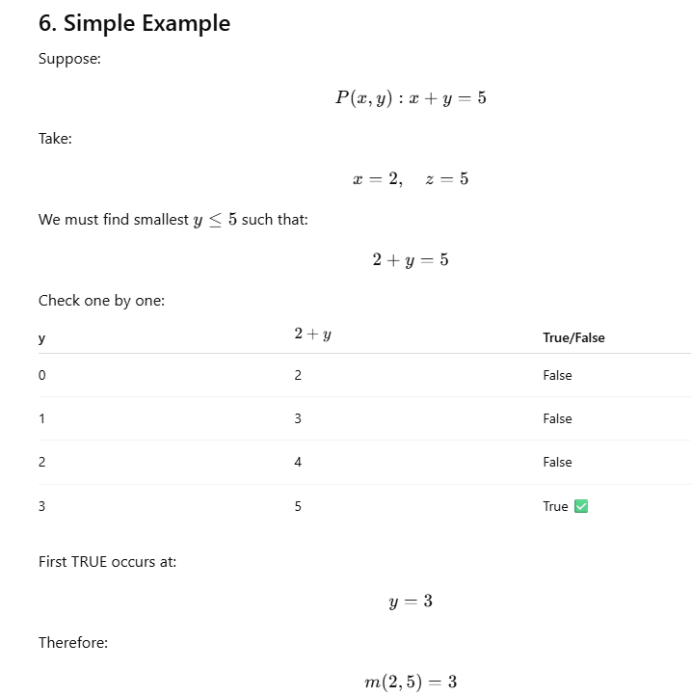
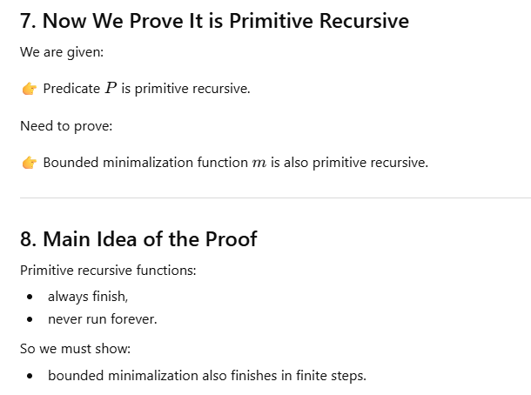
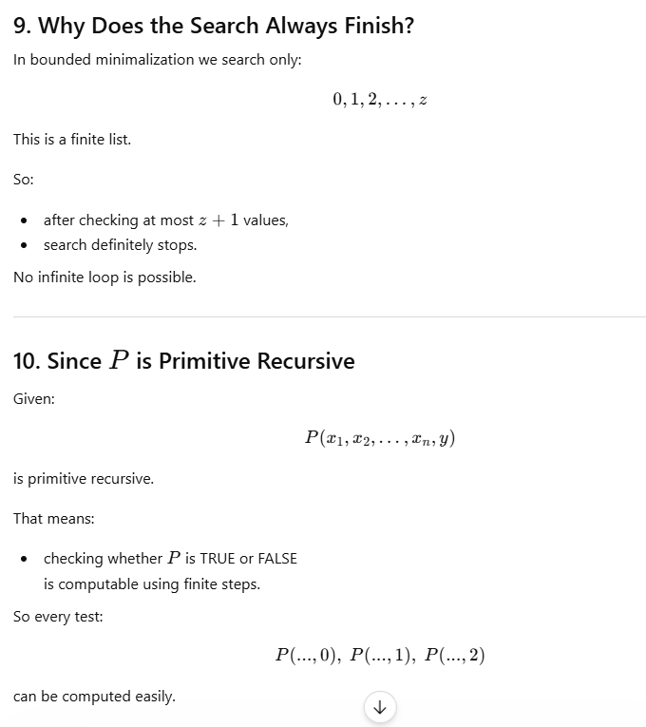
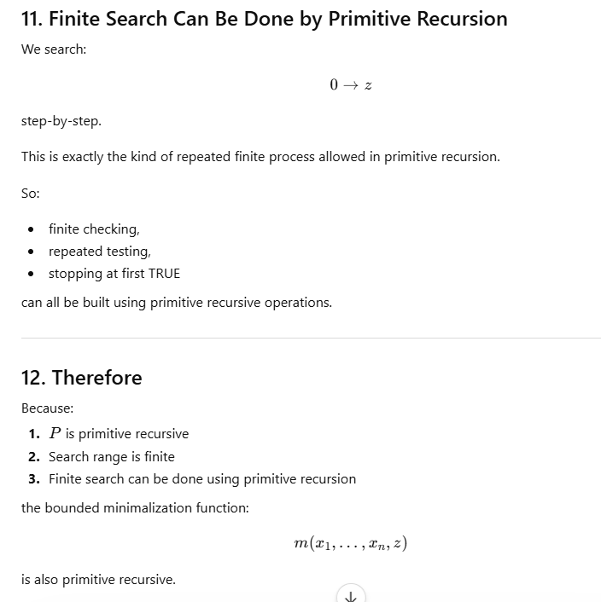

7. Define and explain Bounded Quantification. (7M)
